UNITED STATES

SECURITIES AND EXCHANGE COMMISSION
Washington, D.C. 20549

SCHEDULE 14A

Proxy Statement Pursuant to Section 14(a) of the

Securities Exchange Act of 1934
(Amendment No. )

Filed by the Registrant ☐

Filed by a Party other than the Registrant ☒

Check the appropriate box:

- Preliminary Proxy Statement

- Confidential, for Use of the Commission Only (as permitted by Rule 14a-6(e)(2))

- Definitive Proxy Statement

- Definitive Additional Materials

- Soliciting Material under § 240.14a-12

VAIL RESORTS, INC.

(Name of Registrant as Specified In Its Charter)

OASIS MANAGEMENT COMPANY LTD.

OASIS INVESTMENTS II MASTER FUND LTD.
SETH FISCHER
ROBERT A. CHAPEK
M. ASHTON HUDSON
(Name of Person(s) Filing Proxy Statement, if other than the Registrant)

Payment of Filing Fee (Check all boxes that apply):

- No fee required

- Fee paid previously with preliminary materials

- Fee computed on table in exhibit required by Item 25(b) per Exchange Act Rules 14a-6(i)(1) and 0-11

From time to time, Oasis Management Company Ltd. may publish or post the following materials on its social media channels to its website, liftingthevail.oasiscm.com, and/or appear in digital advertising.
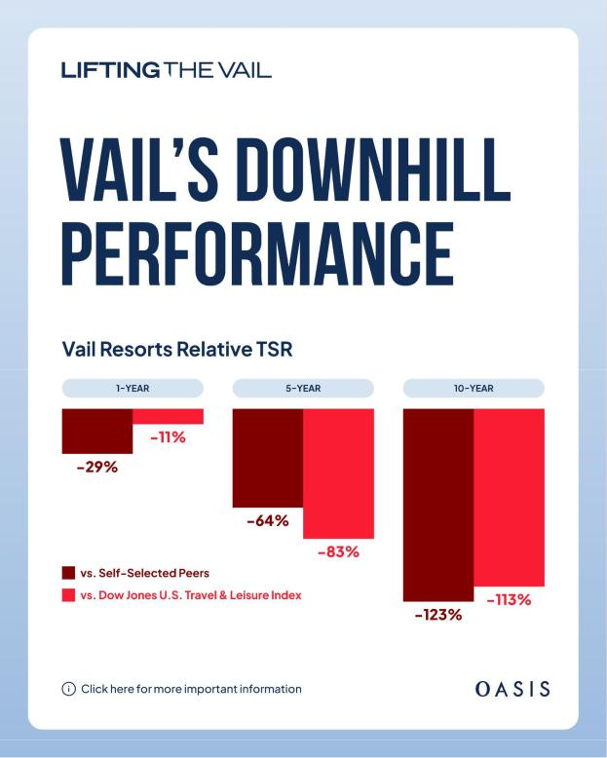

Copy: Oasis believes that Vail Resorts (NYSE: MTN), despite its irreplaceable assets, robust competitive position and attractive customer base, has persistently underperformed. $MTN stock has dropped more than 50% over the past five years, erasing $8B+ in value. #LiftingTheVail

Headline: Vail Resorts: Iconic Properties, Persistent Underperformance | Oasis
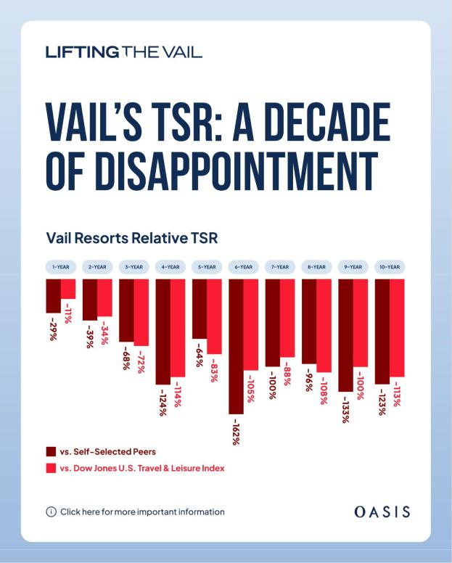

Copy: Vail Resorts’ (NYSE: MTN) relative total shareholder return has lagged Vail’s self-selected peers and the Dow Jones U.S. Travel & Leisure Index for each of the last 10 years. Oasis, which owns about 9.6% of $MTN stock, thinks shareholders deserve better. #LiftingTheVail

Headline: Vail Resorts TSR’s Long Slide | Oasis

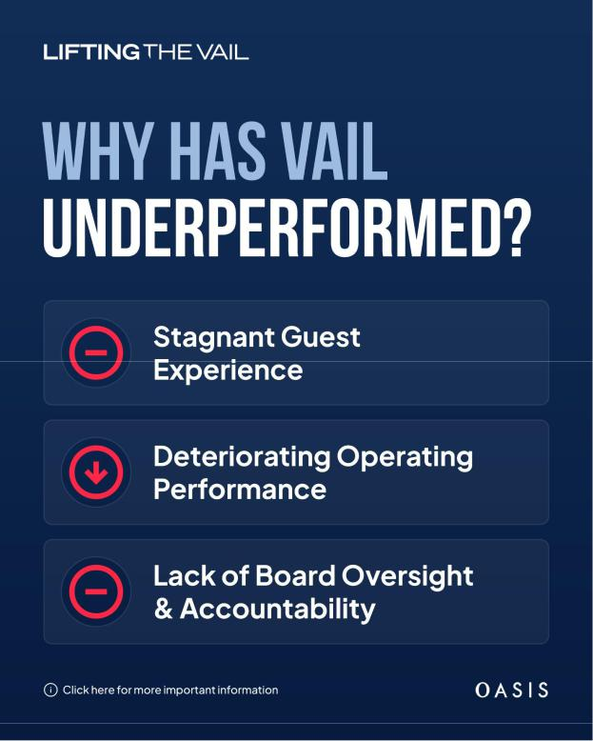

Copy: Vail Resorts (NYSE: MTN) owns some of the world’s most iconic ski resorts. Why has its stock underperformed for so long? Oasis thinks the stagnant guest experience, weak operating performance, and a lack of Board oversight are responsible. #LiftingTheVail

Headline: Oasis Targets Vail’s Stagnant Guest Experience, Poor Board Oversight
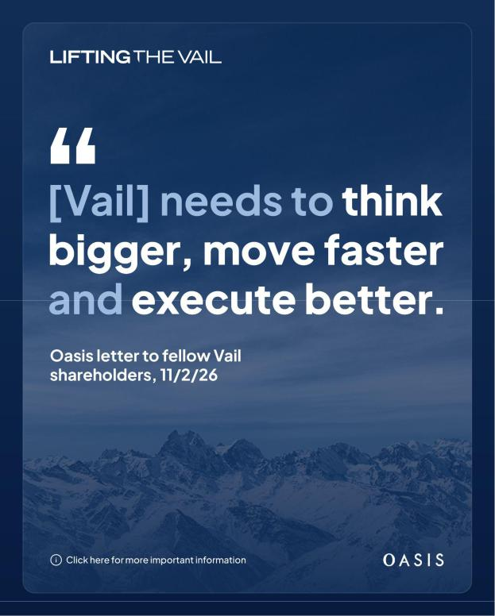

Copy: Oasis thinks Vail Resorts (NYSE: MTN) has all the essential attributes to deliver unforgettable guest experiences and sustainable shareholder value. The missing element? Board oversight and accountability. #LiftingTheVail

Headline: Despite Challenges, Vail Can Get Back on Its Edges | Oasis

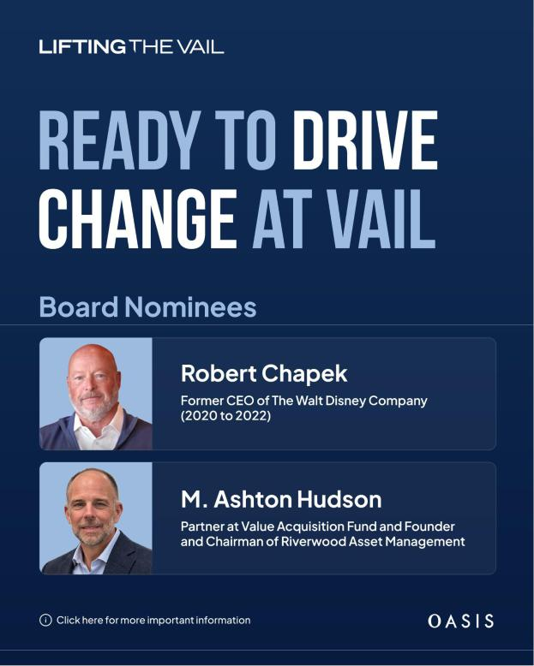

Copy: To strengthen Vail Resorts’ (NYSE: MTN) Board, Oasis has nominated Robert Chapek, former CEO of the Walt Disney Co., and M. Ashton Hudson, experienced investor, entrepreneur, director and attorney, to help drive best-in-class performance for all stakeholders. #LiftingTheVail

Headline: Oasis Nominates Two Highly Qualified Board Members for Vail Resorts

Lifting the Vail: Google Search Ads

Headlines

- Letter to Shareholders

- Read Oasis’ letter to investors

- See the case for change at Vail

