UNITED STATES

SECURITIES AND EXCHANGE COMMISSION
Washington, D.C. 20549

SCHEDULE 14A

Proxy Statement Pursuant to Section 14(a) of the

Securities Exchange Act of 1934
(Amendment No. )

Filed by the Registrant ☐

Filed by a Party other than the Registrant ☒

Check the appropriate box:

- Preliminary Proxy Statement

- Confidential, for Use of the Commission Only (as permitted by Rule 14a-6(e)(2))

- Definitive Proxy Statement

- Definitive Additional Materials

- Soliciting Material under § 240.14a-12

VAIL RESORTS, INC.

(Name of Registrant as Specified In Its Charter)

OASIS MANAGEMENT COMPANY LTD.

OASIS INVESTMENTS II MASTER FUND LTD.
SETH FISCHER
ROBERT A. CHAPEK
M. ASHTON HUDSON
(Name of Person(s) Filing Proxy Statement, if other than the Registrant)

Payment of Filing Fee (Check all boxes that apply):

- No fee required

- Fee paid previously with preliminary materials

- Fee computed on table in exhibit required by Item 25(b) per Exchange Act Rules 14a-6(i)(1) and 0-11

On November 2, 2026, Oasis Management Company Ltd. (“Oasis”) issued a press release, which contains a letter to shareholders of Vail Resorts, Inc. (the “Company”), a copy of which is attached hereto as Exhibit 1 and incorporated herein by reference.

Also on November 2, 2026, Oasis launched a website, liftingthevail.oasiscm.com, to communicate with the shareholders of the Company, the contents of which are attached hereto as Exhibit 2 and incorporated herein by reference.

In addition, the contents included in Exhibit 3 hereto and incorporated by reference, will, from time to time, appear in digital advertising or across Oasis’ dedicated social media platforms.

Exhibit 1

Oasis Management Sends Letter to Vail Resorts Shareholders in Connection with the Company's 2026 Annual Meeting

Highlights Prolonged Stock Price Underperformance, Operational Mismanagement and Failed Board Oversight

Outlines Initiatives to Reinvigorate Customer Loyalty, Restore Growth and Deliver Better Outcomes for Guests, Employees and Shareholders

Launches Website to Provide Shareholders with Additional Information

Urges Shareholders to Vote "FOR" Robert Chapek and M. Ashton Hudson on the BLUE Proxy Card

AUSTIN, Texas, Nov. 2, 2026 /PRNewswire/ -- Oasis Management Company Ltd. ("Oasis"), the manager of funds that own approximately 9.6% of the outstanding common shares of Vail Resorts, Inc. ("Vail Resorts" or the "Company") (NYSE: MTN), today released a letter to Vail Resorts shareholders in connection with its nomination of Robert Chapek and M. Ashton Hudson for election to the Vail Resorts Board of Directors at the Company's 2026 Annual Meeting of Stockholders (the "Annual Meeting"), which is scheduled to be held on December 14, 2026. Oasis also launched a website, liftingthevail.oasiscm.com, to provide shareholders with additional information in connection with the Annual Meeting.

"Vail Resorts is an iconic company, with a valuable network of irreplaceable mountain resorts," said Seth H. Fischer, Founder and Chief Investment Officer of Oasis. "Despite its competitive advantages, however, Vail Resorts has gone downhill. The Company has been operationally mismanaged, in our view, resulting in a stagnant guest experience, deteriorating operating performance and disappointing returns for shareholders."

Mr. Fischer continued, "It's time to get Vail Resorts back on its edges. We have identified concrete initiatives that we believe can help reinvigorate customer loyalty, restore growth and deliver better outcomes for guests, employees and shareholders. Our goal is to make Vail Resorts better, not break it up. We encourage shareholders to support this much-needed change by voting for our highly qualified, independent nominees, Robert Chapek and M. Ashton Hudson. With your help, Lifting the Vail is possible."

The full text of the letter is below and available to view online on our website.

Dear Fellow Vail Resorts Shareholders:

The Oasis Group^{[1]} owns approximately 9.6% of Vail Resorts stock, worth more than half a billion dollars.^{[2]} Like you, we are enthusiastic owners of this iconic company because we believe it is one of the leading hospitality businesses in the world, with a valuable network of irreplaceable mountain resorts, a robust competitive position and a highly attractive customer base.

Despite these advantages, the Company's stock price is down more than 50% over the last five years, erasing more than $8 billion of market

value.^{[3]} In fact, before media reports of our engagement with the Company, Vail Resorts' total shareholder return had significantly underperformed the median of the Company's self-selected peers and the Dow Jones U.S. Travel & Leisure Index over each of the last one, two, three, four, five, six, seven, eight, nine and ten years!^{[4]}

This persistent underperformance has coincided with multi-year declines in North American skier visits, pass unit sales and Resort Reported EBITDA margins, along with frequent guidance cuts, which we believe have damaged the credibility of management and the Board. In each of the last three fiscal years, the Company lowered its earnings guidance twice and ultimately missed the midpoint of its initial guidance by approximately 10% on average.^{[5]}

The Company's CEO, who has served on the Board for 30 years and has led the Company as CEO or Executive Chairperson for 20 years, is asking shareholders for patience. In the Company's proxy statement, Mr. Katz writes that the Company is at "just the beginning" of its "new

strategy"^{[6]} and the Board claims that recent initiatives "are only just starting to demonstrate their potential."^{[7]} Shareholders have heard similar promises before, and many earlier strategic initiatives implemented with the Board's approval have failed to deliver sustainable earnings growth or shareholder value.^{[8]}

The Company's problems are not new, even if Mr. Katz's "focus" on solutions is. Vail Resorts' North American customer base has been shrinking for three consecutive fiscal years.^{[9]} During the 2024-2025 season, when industrywide skier visits rose 3%, visits to the Company's
resorts fell 3%.^{[10]} During the 2025-2026 season, the Company's North American skier visits fell by 15%, underperforming the industry decline of 10%.^{[11]}

Despite the Board's proclamations of a turnaround,^{[12]} unit sales of the Company's pass products have declined approximately 12% for the upcoming 2026-2027 season, an acceleration from two consecutive seasons of approximately 3% year-over-year declines.^{[13]} And Wall Street analysts who closely follow Vail Resorts have assessed the Company's strategy and seemingly do not share the Board's view that "progress"^{[14]} is underway, having reduced their EBITDA estimates for both fiscal 2027 and 2028 by an average of 11% and 13%, respectively, over the last 12 months.^{[15]}

Vail Resorts Has Gone Downhill

With so many competitive advantages, why has the Company performed so poorly for shareholders?

The Guest Experience Has Stagnated. The guest experience has suffered as a result of long lift lines,^{[16]} overcrowding^{[17]} and escalating food prices,^{[18]} with too few options and experiences offered for both value-conscious and premium customers. Today, just one Vail Resorts property ranks among the top ten ski resorts in the Eastern or Western United States in SKI Magazine's annual
reader survey.^{[19]} Vail Resorts' inattention to the guest experience was brought into sharp focus during the 2024-2025 holiday season ski patrol strike at Park City Mountain, which arose from a dispute over a $2 increase in the hourly base wage, among other requests,
- and which left guests facing closed terrain and long lines during the critical holiday period.

Operating Performance Has Deteriorated. Since fiscal 2016, the Company has more than tripled the size of its resort portfolio, expanding from 12 to 42 properties, while increasing Resort net revenue by 79%.^{[21]} Yet, the Company has not realized the operating leverage and efficiencies that should accompany such a significant increase in scale. Resort Reported EBITDA margins have declined
for four consecutive years, reaching their lowest level since fiscal 2014 (excluding the pandemic-impacted fiscal 2020).^{[22]} Moreover, despite an approximately 45% increase in effective ticket prices since fiscal 2016, Resort Reported EBITDA per skier visit has increased by only 8%.^{[23]}

The Board Has Failed to Provide Oversight and Accountability. The Board has, in our view, failed in its most fundamental responsibilities: selecting the Company's executive team, overseeing strategy and execution, appropriately aligning executive compensation with shareholder value and ensuring that the Board itself has the experience the Company needs. As noted, Mr. Katz has led the Company as either CEO or Executive Chairperson for more than 20 years, including throughout the last five years during which execution has faltered and the guest experience has deteriorated. The long-term incentive plan has no performance-based criteria, and the Board touts that the compensation structure will "deliver some value even during periods of market or stock price underperformance."^{[24]} And, over the past two-and-a-half years, the Board has added just one new director—which came more than a year after we first raised the topic of Board refreshment with the Company in July 2025, and only after our engagement became public.^{[25]}

The problem is not with the assets the Company owns, in our view, but with how the Company has mismanaged those assets. Unfortunately, this Board appears content with continued stagnation and underperformance. Under the current Board-approved plan, management is forecasting fiscal 2027 Resort Reported EBITDA that, at the midpoint of the guidance range, is essentially unchanged from what the Company earned five years ago in fiscal 2022, with a profit margin that is more than 600 basis points below the fiscal 2022 margin.^{[26]}

Lifting the Vail

The Company needs to think bigger, move faster and execute better. In short, it is time to get Vail Resorts back on its edges.

Our plan is about making the Company better, not breaking it up. We have identified concrete initiatives that we believe can help reinvigorate customer loyalty, restore growth and deliver better outcomes for guests, employees and shareholders, including:

- Introducing new and expanded pass and ticket offerings and customer experiences that raise the ceiling and lower the floor on price and access;

- Improving food and beverage quality, variety and value at every price point;

- Expanding year-round use of the Company's mountain assets;

- Modernizing the Company's marketing strategy to deepen connections with locals and core customers while appealing to new and less frequent guests;

- Developing a more compelling loyalty program to strengthen customer engagement and encourage repeat visits; and

- Upgrading technology to enhance the customer experience and improve operational efficiency.

Through these initiatives, we see a credible path to meaningful profit margin expansion, renewed earnings growth and a re-rating of the Company's valuation multiple, which we believe would create substantial shareholder value.

We have sought to work constructively with management and the Board to institute what we regard as critical improvements to the Company's operations and strategy. The Company now claims that we "have yet to offer a credible plan to improve shareholder returns."
- Yet according to the Company's own proxy statement, Mr. Katz acknowledged that "almost every action the Company took in the last
year was fully aligned with the feedback" we provided in July 2025.^{[28]} We welcome any effort to make Vail Resorts a better company, but its recent initiatives have been too little, too late and, to date, largely ineffective. Mr. Katz himself admits that the Company's recent performance has "not met [his] expectations or the full potential of [the] business."^{[29]} We agree.

Rather than engage on the merits, the Board has sought to distract shareholders by fabricating a theory that we are working "in collaboration with Matthew Prince,"^{[30]} a resident of Park City who has expressed an interest in acquiring the Company's resort there. Let us be clear: We are not coordinating with Mr. Prince in any way. Neither of our two nominees has ever spoken with Mr. Prince. And, notably, our plan for improving Vail Resorts' performance does not include moving to an asset-light model. In fact, we regard the Company's integrated resort network as one of its greatest competitive strengths.

The Oasis Nominees Are Well Positioned to Drive Change

We believe shareholders should expect more candor and ambition from their fiduciaries and better performance from a company with Vail Resorts' extraordinary assets and competitive advantages.

Realizing the Company's full potential will require new directors with a mandate to challenge management, demand better performance and oversee the execution of a more ambitious plan.

For that role, we have nominated two candidates, each of whom is independent of Oasis and well positioned to help address the Company's operational and governance failures:

Robert Chapek is the former CEO of The Walt Disney Company and former Chairman of Disney's Parks, Experiences and Products segment, where he oversaw more than $20 billion of investment in parks, hotels and cruise ships. As Chairman of Disney's parks business, Mr. Chapek delivered five consecutive years of record operating income and more than 500 basis points of margin expansion. And as CEO, Mr. Chapek oversaw the early growth of Disney's direct-to-consumer business, including Disney+, which grew from $2.0 billion in quarterly revenue prior to his appointment to approximately $4.9 billion in quarterly revenue. We believe his experience leading one of the largest hospitality businesses in the world would help Vail Resorts sharpen its focus on the guest experience and improve resort operations.

M. Ashton Hudson is a Partner at Value Acquisition Fund and Founder and Chairman of Riverwood Asset Management. Mr. Hudson chaired JEA, one of the largest municipally owned utilities in the U.S., and served on the Audit, Compensation and Governance Committees of NYSE-listed Forestar Group. A seasoned public and private company director and former corporate attorney with direct experience in succession planning and executive compensation, we believe Mr. Hudson would help ensure effective governance and strengthen the Board's oversight.

Our nominees do not aim to manage the Company from the boardroom. Rather, they aim to exercise independent judgment, challenge assumptions, establish rigorous performance targets and hold leadership accountable for execution—all with a sense of urgency that we believe has been sorely lacking among the incumbent directors.

We therefore encourage you to vote "FOR" both of our nominees on the enclosed BLUE proxy card, to enable them to pursue this ambitious agenda. To make room for our director candidates, we recommend that you "WITHHOLD" your vote on two of the Company's nominees, Peter A. Vaughn and Michele Romanow. We also recommend that you "WITHHOLD" your vote on Gregory S. Meyer, an individual shareholder who has nominated himself for election to the Board.

Vail Resorts' extraordinary mountain assets can deliver unforgettable experiences for guests, opportunities for employees and mountain communities and sustainable value for shareholders. With your help, Lifting the Vail is possible, and we can deliver on this promise.

Thank you for your support.

Sincerely,
Oasis Management Company Ltd.

If you have any questions or require any assistance with voting your shares, please call:

Innisfree M&A Incorporated

500 Fifth Avenue, 21st Floor
New York, NY 10110
Stockholders may call toll-free at (877) 456-3507

Brokers, banks and other nominees may call collect at (212) 750-5833

About Oasis Management Company Ltd.

Oasis Management Company Ltd. manages private investment funds focused on opportunities in a wide array of asset classes across countries and sectors. Oasis was founded in 2002 by Seth H. Fischer, who leads the firm as its Chief Investment Officer. More information about Oasis is available at https://oasiscm.com.

Disclaimer

Oasis is not and should not be regarded or deemed in any way whatsoever to be making an offer, a solicitation of an offer, or any advice, invitation or inducement to enter into or conclude any transaction. Further, this press release does not recommend the purchase or sale of any security nor is it an offer to sell or a solicitation of an offer to buy any security. Nothing in this press release is intended to be, nor should it be construed or used as, investment, tax or legal advice.

Except as otherwise set forth herein, this press release represents the opinions, interpretations and estimates of Oasis. Oasis reserves the right to change any of its opinions expressed in this press release at any time as it deems appropriate and disclaims any obligation to notify the market or any other party of any such change, except as required by law.

The information contained herein is derived from publicly available information deemed by Oasis to be reliable. The information herein may contain forward-looking statements which can be identified by the fact that they do not relate strictly to historical or current facts and include, without limitation, words such as "may," "will," "expects," "believes," "anticipates," "plans," "estimates," "projects," "targets," "forecasts,"

"seeks," "could" or the negative of such terms or other variations on such terms or comparable terminology. Similarly, statements that describe Oasis's objectives, plans or goals are forward-looking. Any forward-looking statements are based on Oasis's current intent, subjective belief, expectations, estimates and projections. These statements are not guarantees of future performance and are subject to change due to a variety of factors, including fluctuating market conditions and economic factors, and involve risks, uncertainties, assumptions and other factors that are difficult to predict or quantify, are beyond Oasis's control and that could cause actual results to differ materially. Accordingly, you should not rely upon forward-looking statements as a prediction of actual results and actual results may vary materially from what is expressed in or indicated by the forward-looking statements.

Oasis has neither sought nor obtained the consent from any third party to use any statements or information contained herein that have been obtained or derived from statements made or published by such third parties. Any such statements or information should not be viewed as indicating the support of such third parties for the views expressed herein.

Information About the Participants

The Participants (as defined below) intend to file a definitive proxy statement and accompanying proxy card with the Securities and Exchange Commission (the "SEC") to be used in connection with the Annual Meeting. All stockholders of the Company are advised to read the proxy statement and any other relevant documents filed by the Participants with the SEC when they become available, as they will contain important information, including information relating to the Participants. The proxy statement and other relevant documents will be available at no charge on the SEC's website at www.sec.gov.

The "Participants" in the proxy solicitation are expected to be (i) Oasis, (ii) Oasis Investments II Master Fund Ltd., (iii) Seth Fischer, (iv) Robert Chapek, and (v) M. Ashton Hudson. Information about the Participants and a description of their direct or indirect interests, by security holdings or otherwise, is contained in Annex I to the Revised Preliminary Proxy Statement, filed with the SEC on October 30, 2026, which is available at no charge on the SEC's website at www.sec.gov.

Contacts

Media Contact

Taylor Hall
media@oasiscm.com

Investor Contact

Innisfree M&A Incorporated
Larry Miller / Gabrielle Wolf

+1 (212) 750-5833

- "Oasis Group" refers to Oasis Management Company Ltd., Oasis Investments II Master Fund Ltd., Seth Fischer, Robert Chapek, and M. Ashton Hudson.

- Based on Vail Resorts' closing share price on October 30, 2026 and the number of shares beneficially owned by Oasis as disclosed in its revised preliminary proxy statement filed on October 30, 2026.

- FactSet and Bloomberg. Data as of October 30, 2026. Value destruction based on market capitalization change.

- FactSet and Bloomberg. Data as of June 17, 2026, the last trading day prior to media reports that Oasis was considering launching a proxy contest at the Company. "Self-selected peers" refer to the companies referenced in Vail Resorts' 2026 Investors' Conference Presentation for the purpose of comparing free cash flow conversion and include Carnival, Hilton Worldwide Holdings, Hyatt Hotels, Marriott International, MGM Resorts, Norwegian Cruise Line Holdings, Royal Caribbean, Six Flags Entertainment, United Parks & Resorts, Wyndham Hotels & Resorts and Wynn Resorts. Peer data reflects the median. Wyndham Hotels & Resorts data is not included in the 9-Year and 10-Year median calculation due to the Wyndham Hotels & Resorts stock not trading at that time.

- Company filings. "Earnings" refers to Resort Reported EBITDA.

- Company proxy statement, October 30, 2026.

- Company press release and letter to shareholders, October 30, 2026.

- FactSet and Bloomberg. Data as of June 17, 2026. Based on the negative absolute and relative total shareholder returns versus both the median of the Company's self-selected peers ("Self-selected peers" refer to the companies referenced in Vail Resorts' 2026 Investors' Conference Presentation for the purpose of comparing free cash flow conversion and include Carnival, Hilton Worldwide Holdings, Hyatt Hotels, Marriott International, MGM Resorts, Norwegian Cruise Line Holdings, Royal Caribbean, Six Flags Entertainment, United Parks & Resorts, Wyndham Hotels & Resorts and Wynn Resorts. Peer data reflects the median.) and the Dow Jones U.S. Travel & Leisure Index since, for example, the March 2019 announcement of the "Epic for Everyone" strategy, the March 2021 announcement of the Epic Pass price reduction, the September 2024 announcement of the Efficiency Transformation Plan, the August 2025 announcement of "Epic Friend Tickets" and the September 2025 announcement of a "Multi-Year Growth Strategy."

- Company filings.

- Company filings.

- Company filings.

- Company press release and letter to shareholders, October 30, 2026.

- Company press releases reporting North American pass product unit sales through September 20, 2024 (down approximately 3%), September 19, 2025 (down approximately 3%) and September 18, 2026 (down approximately 12%).
- Company press release and letter to shareholders, October 30, 2026.

- FactSet. Estimates as of the first day of each month through October 2026.

- Mead Gruver, "Rare ski patroller strike at largest resort in US causes long lines and closes terrain," AP, January 7, 2025.

- "The Snowballing Problems at Vail Resorts," The Journal Podcast, February 5, 2025.

- Sam Weintraub, "Vail Resorts Epic Experience: The Death of a 20-Year Strategy?," PeakRankings, July 14, 2026.

- Samantha Berman, "The Reader-Ranked Top 20 Resorts in the East for 2026," SKI Magazine, October 29, 2025; Samantha Berman, "The Top 30 Resorts in the West for 2026, Ranked by Readers," SKI Magazine, October 28, 2025.

- Mead Gruver, "Ski patrollers reach deal to end strike at Utah's Park City Mountain Resort," Fox40, January 8, 2025.

- Company filings.

- Company filings.

- Company filings.

- Company proxy statement, October 30, 2026.

- Company proxy statement, October 30, 2026.

- Company filings.

- Company press release and letter to shareholders, October 30, 2026.

- Company proxy statement, October 30, 2026.

- Company proxy statement, October 30, 2026.

- Company press release and letter to shareholders, October 30, 2026.

Exhibit 2
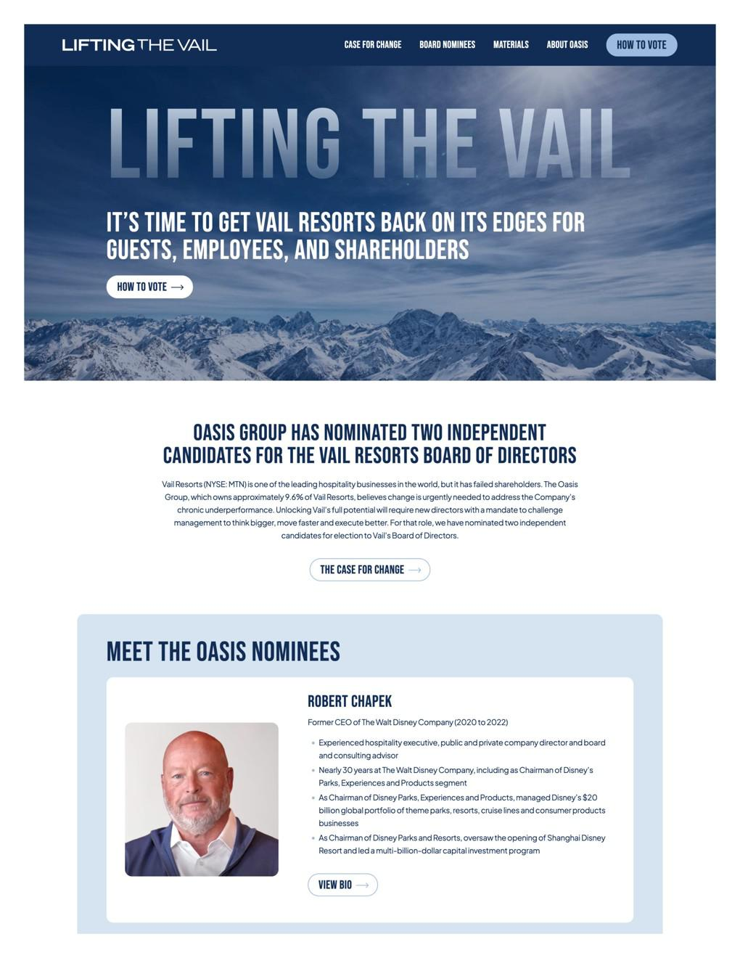

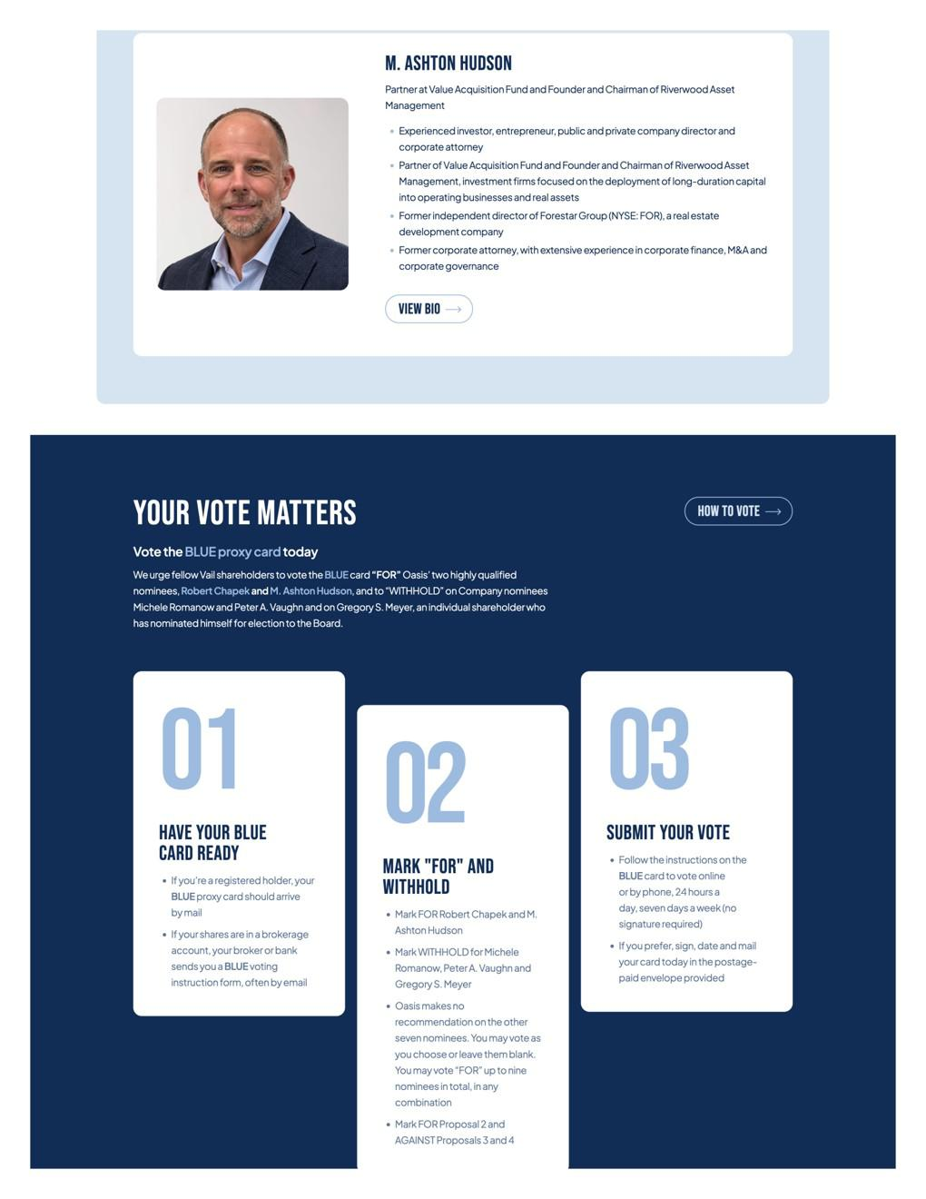

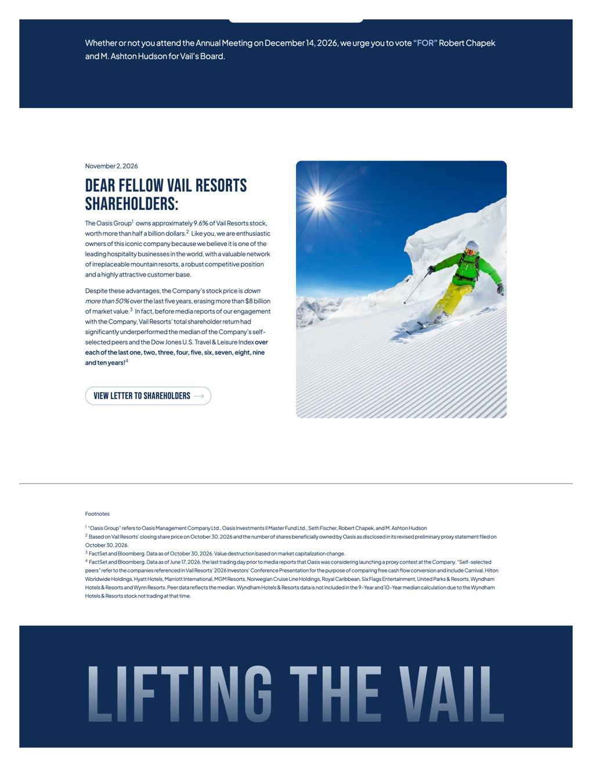

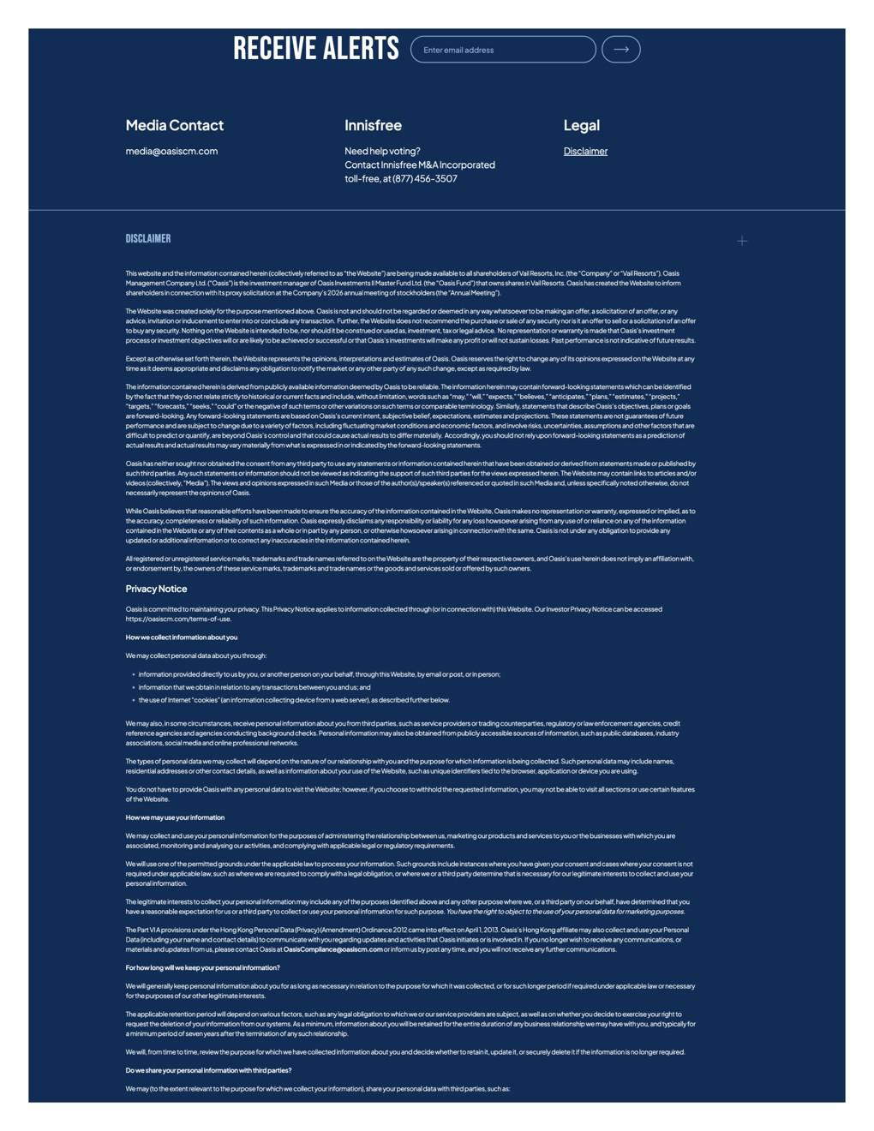

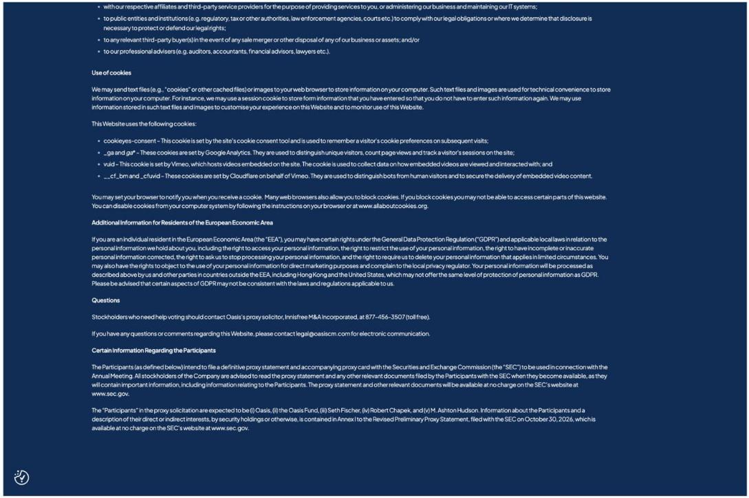

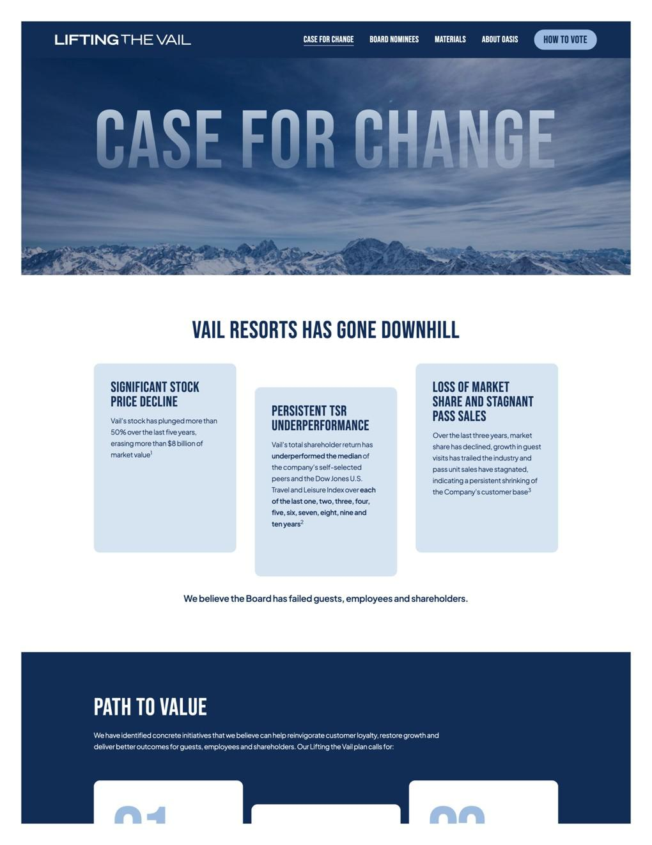

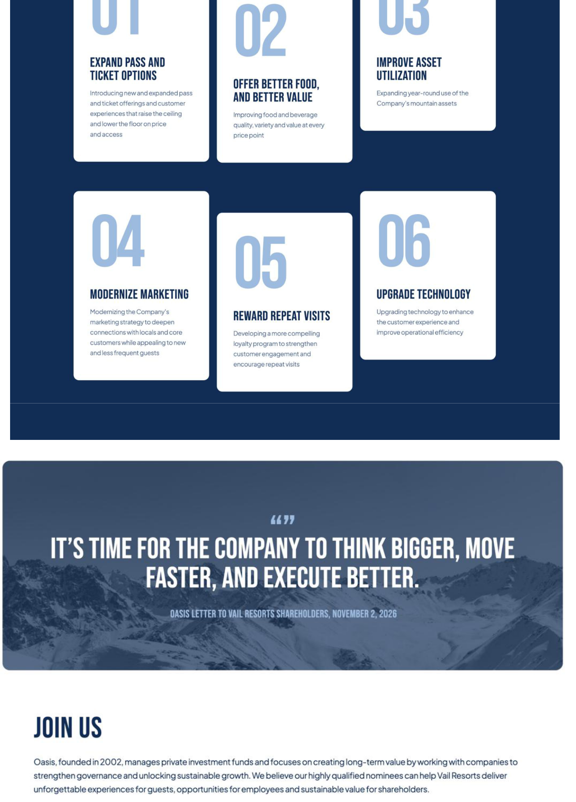

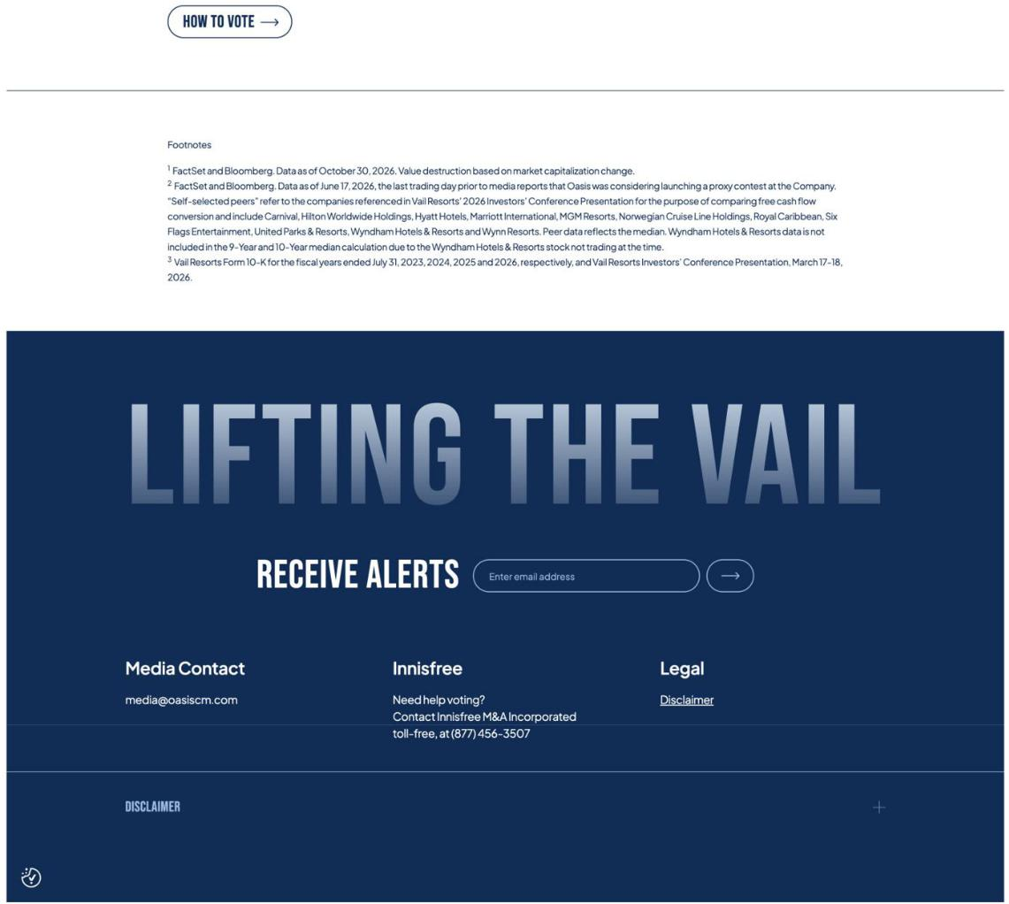

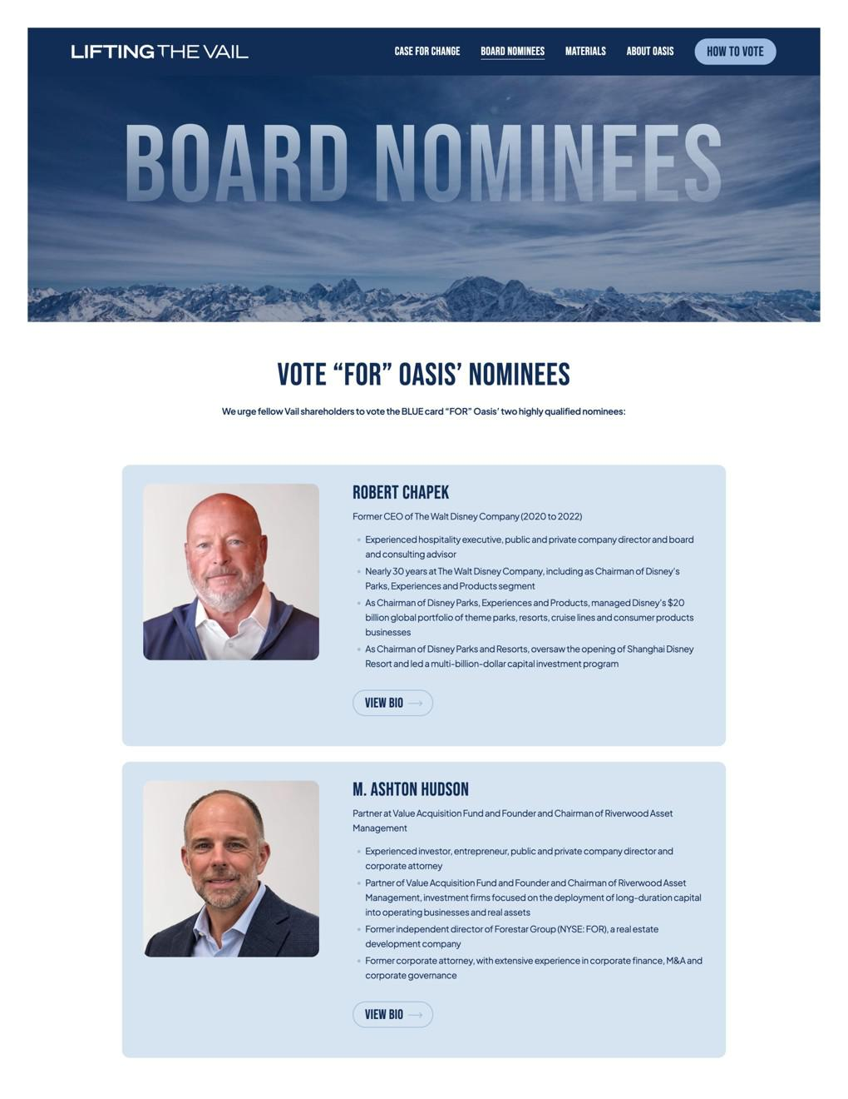

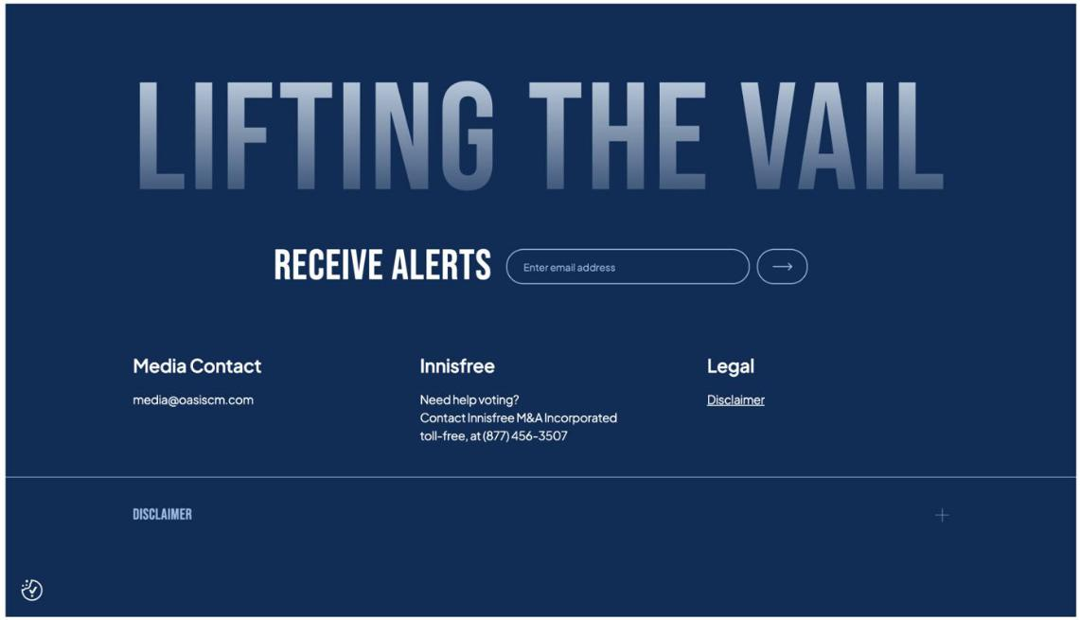

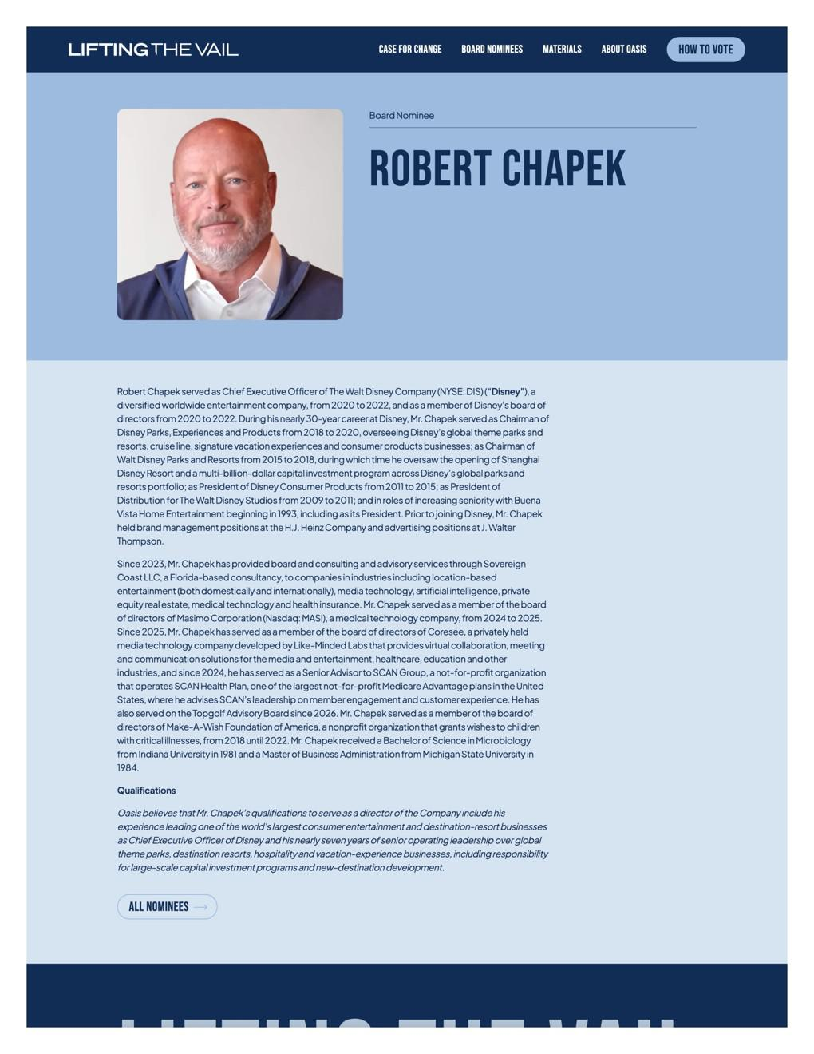

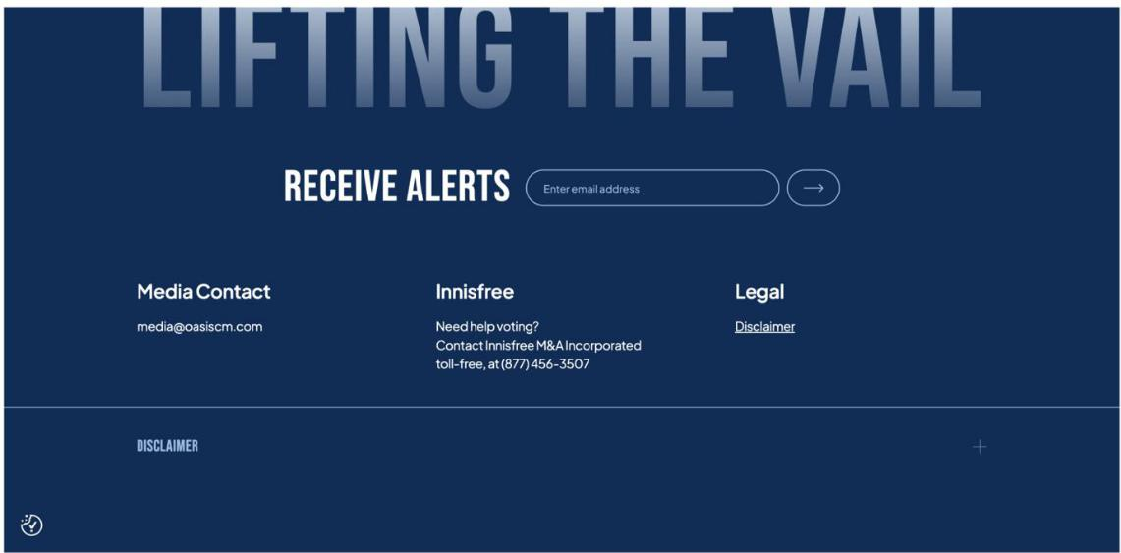

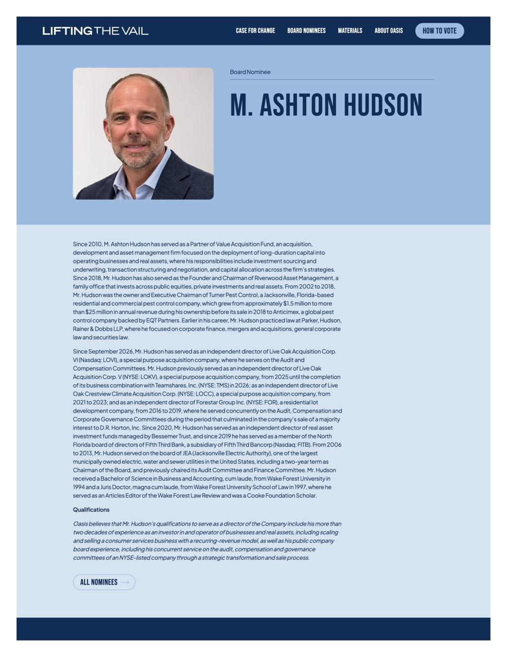

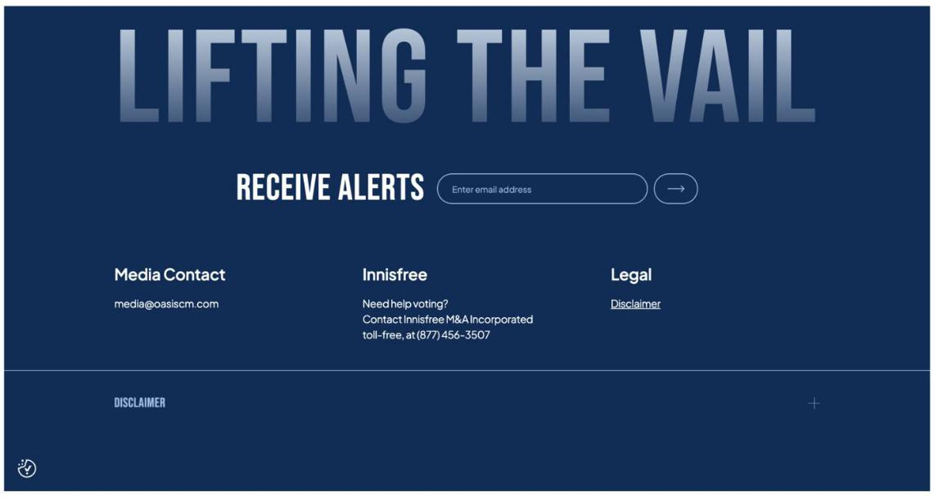

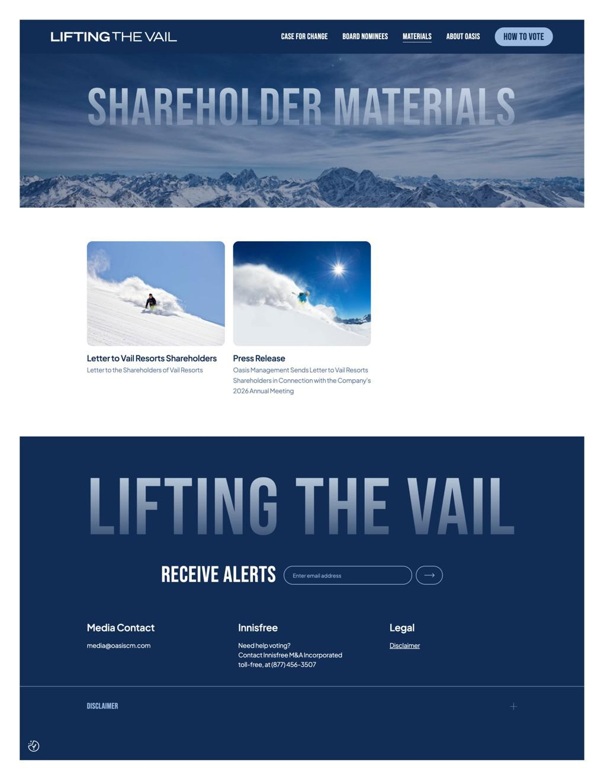

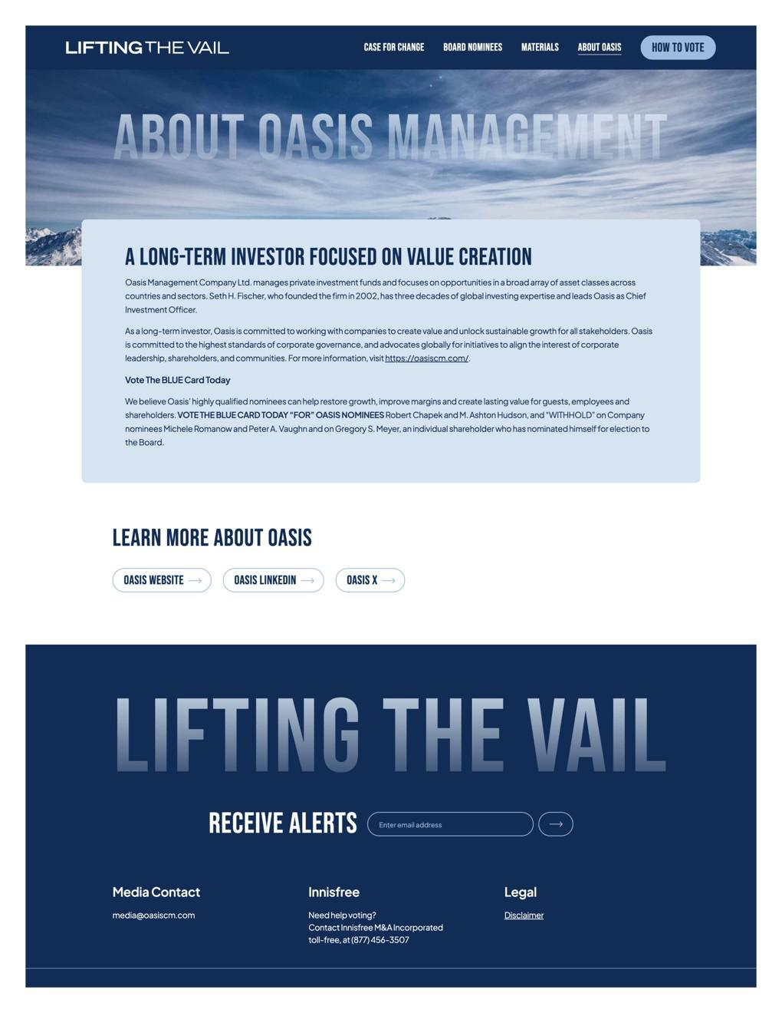



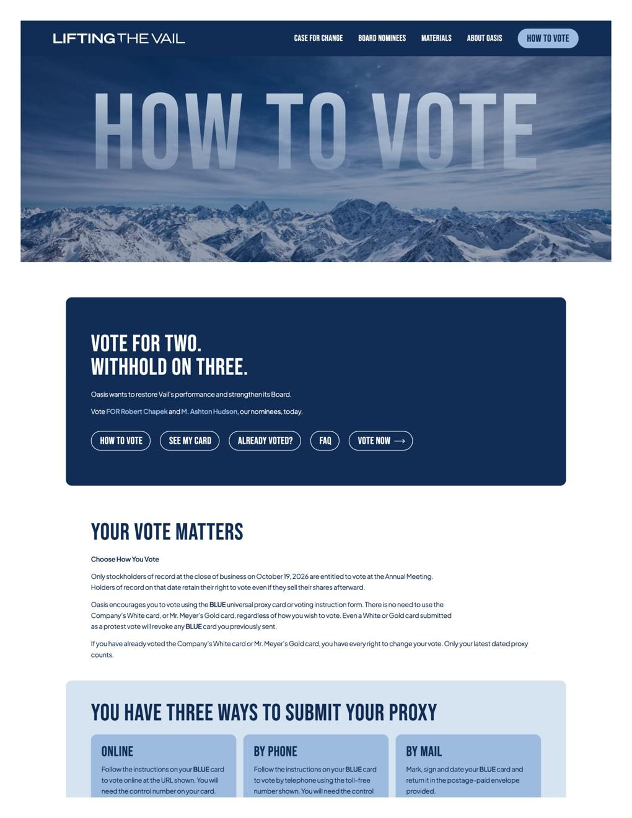

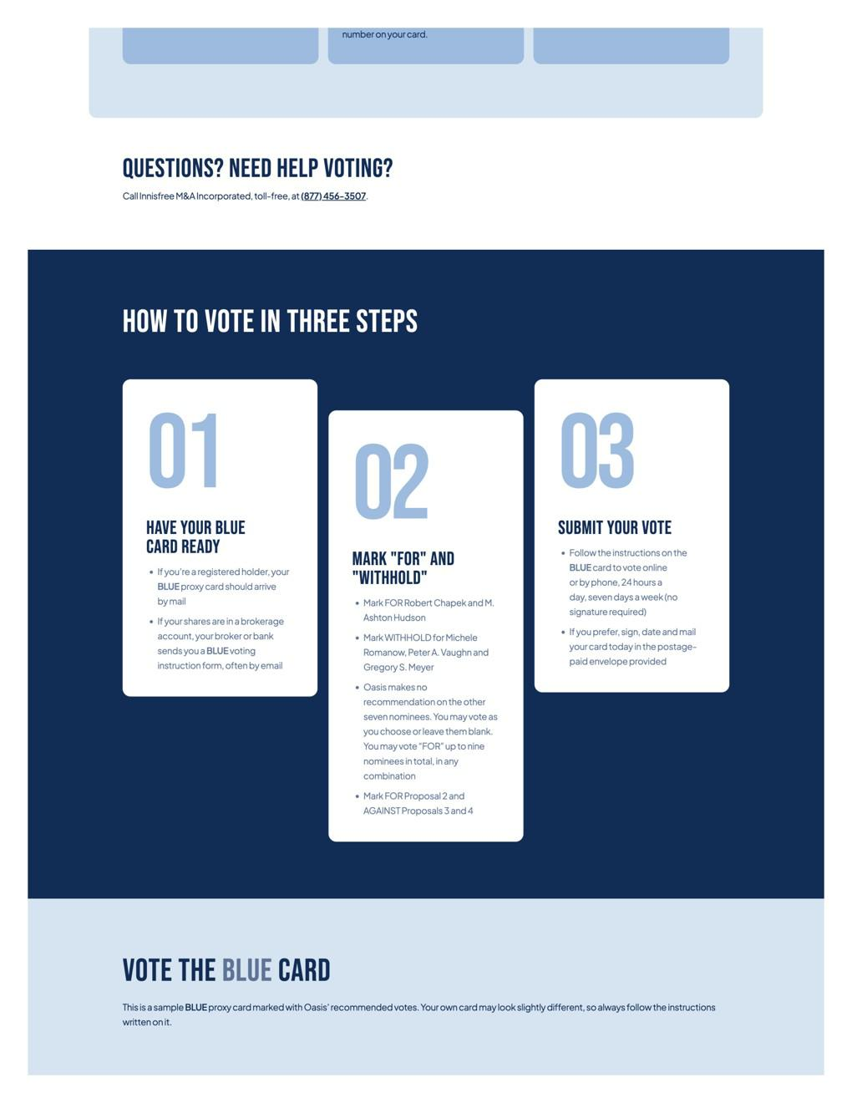

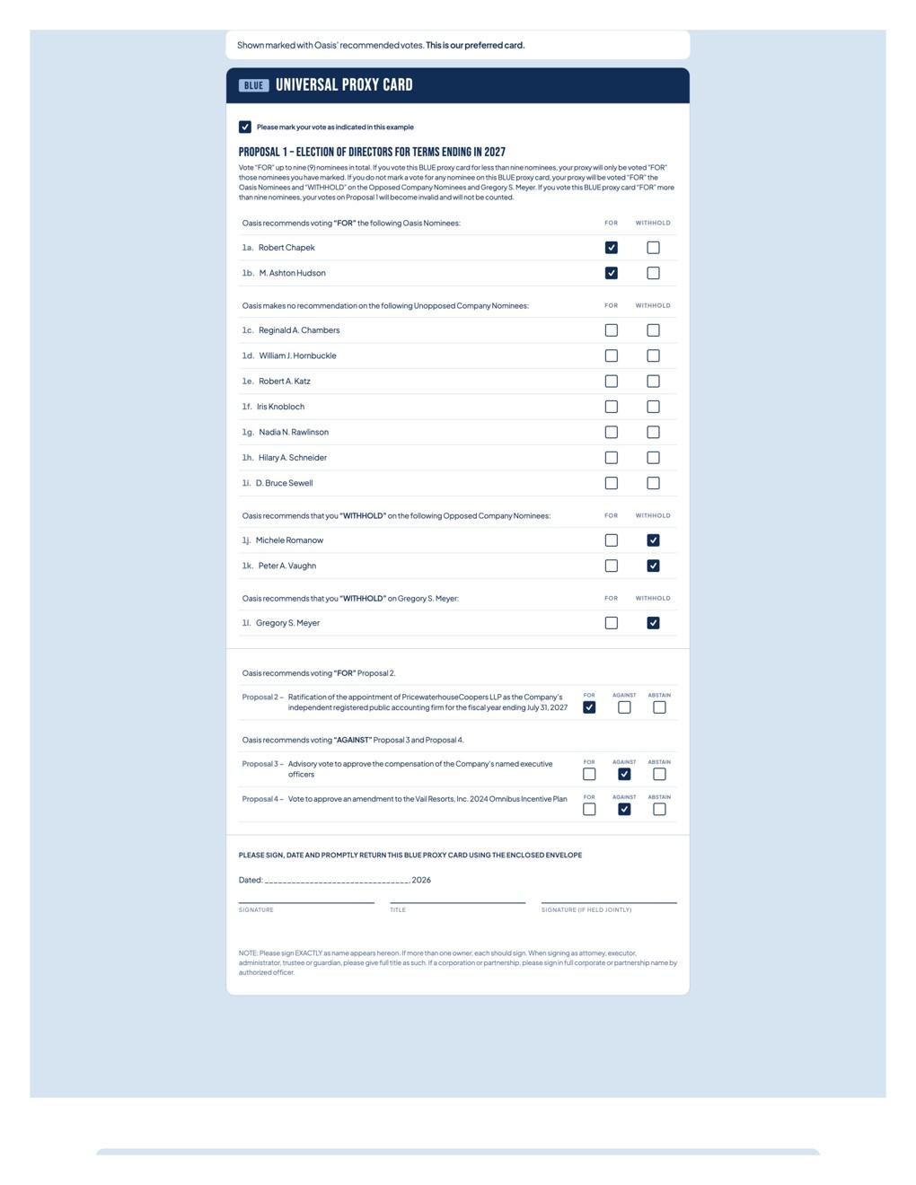

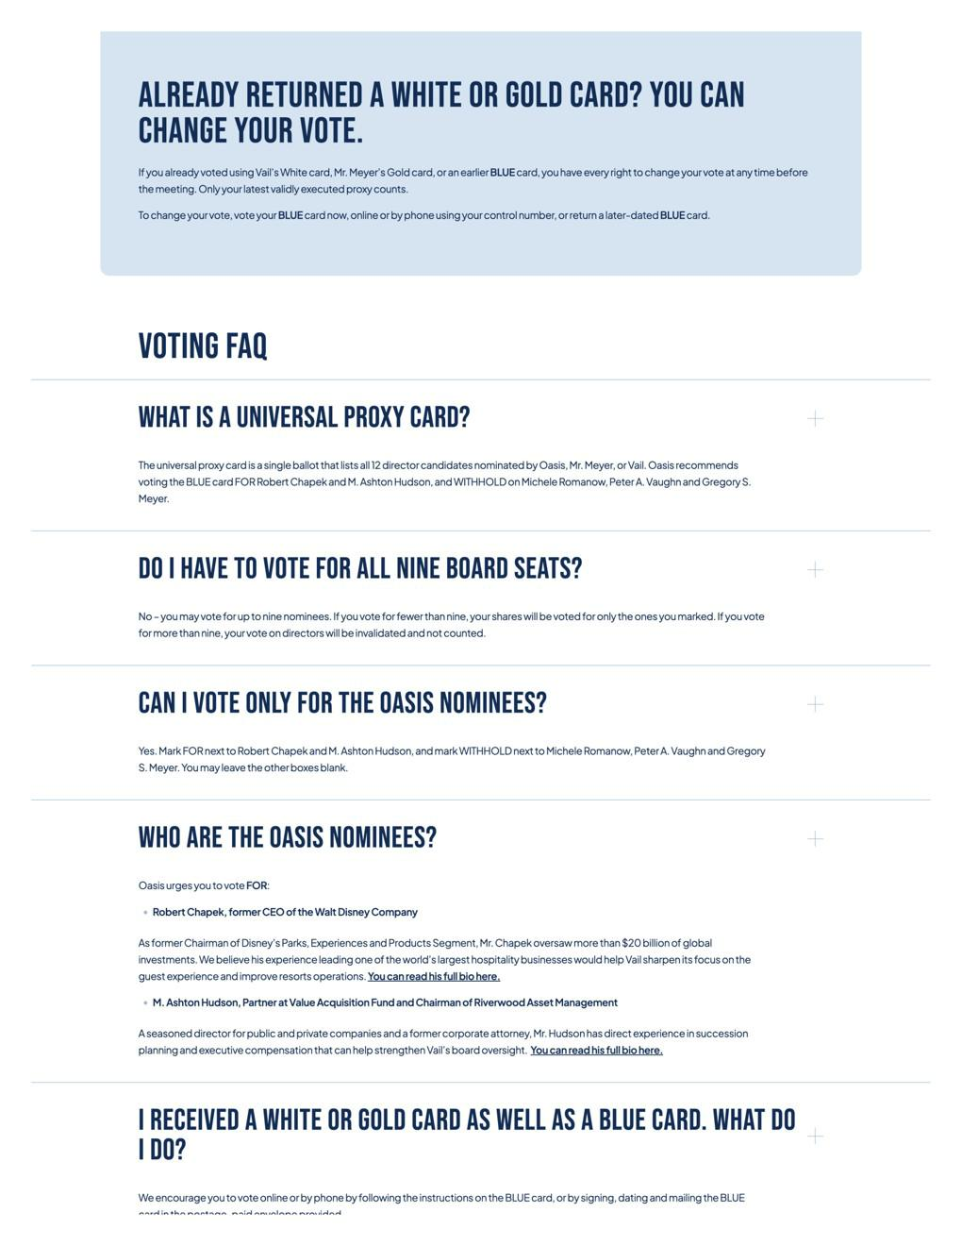

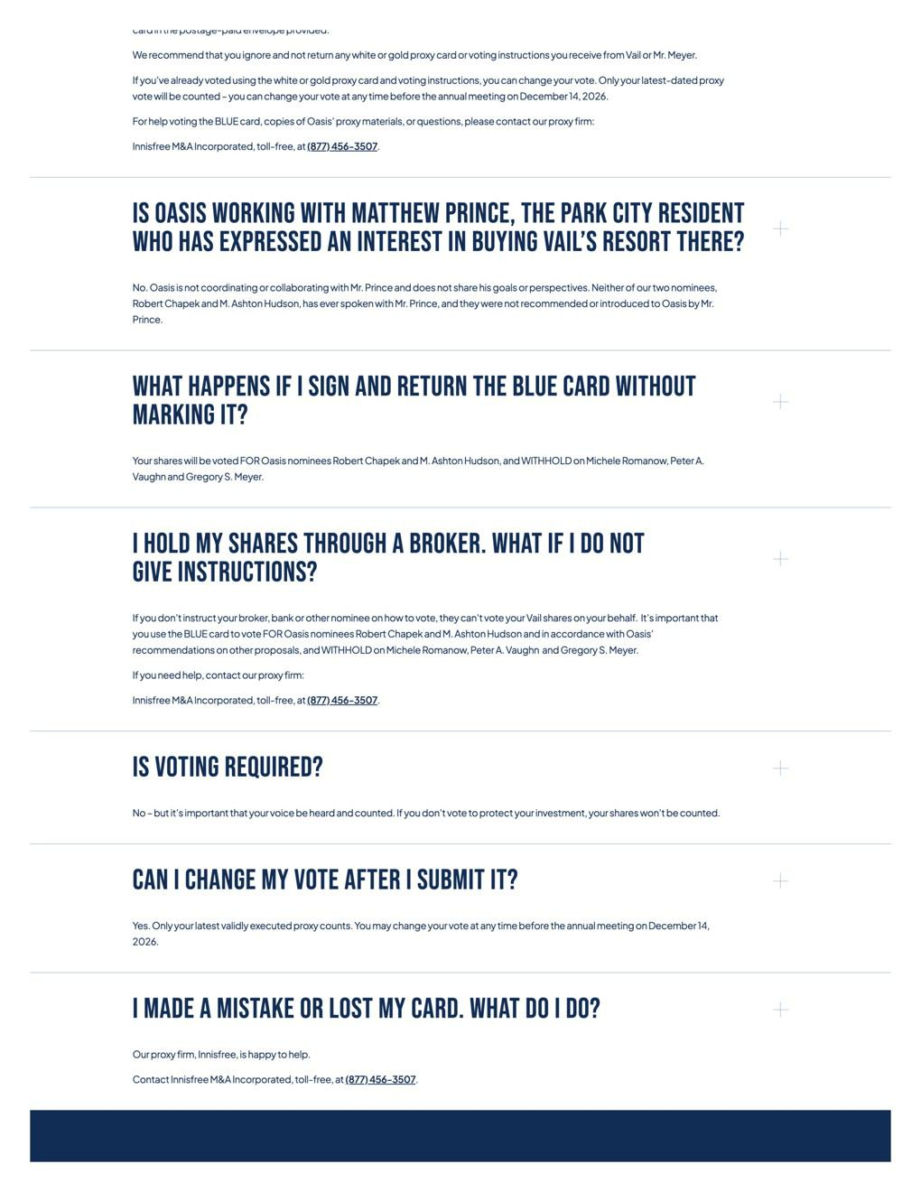

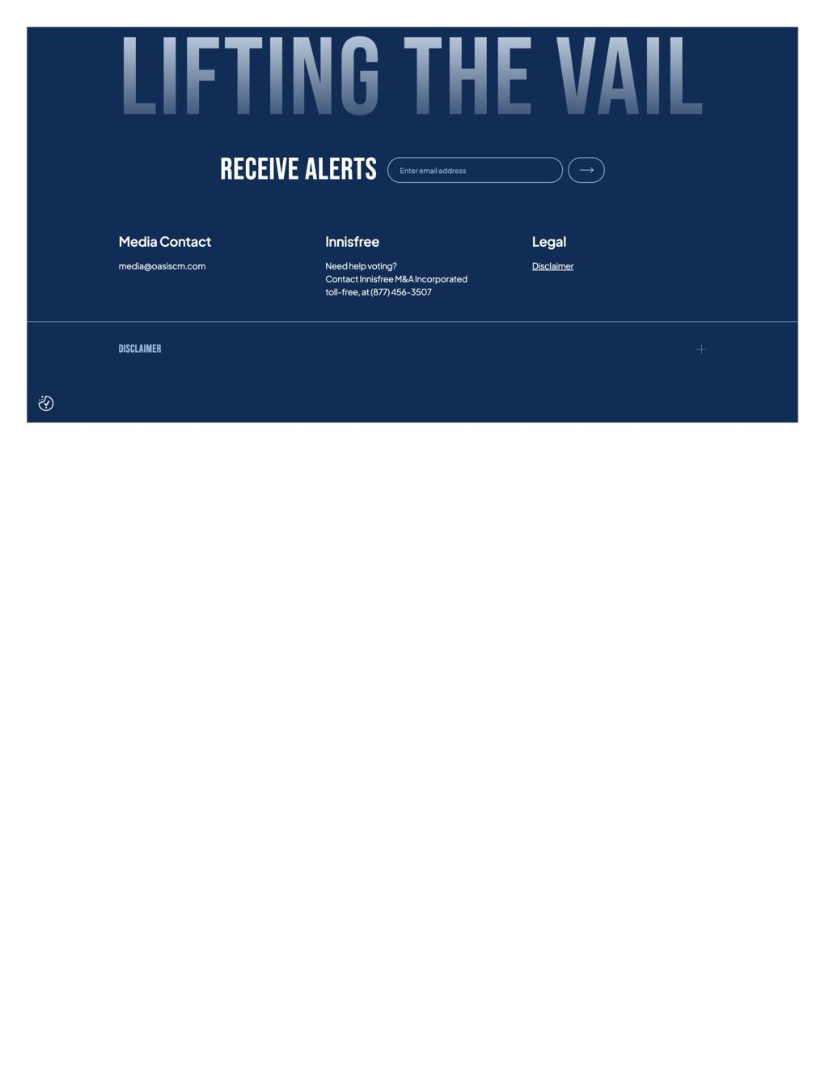

Exhibit 3

Profile Picture


Banner Image


X, Instagram, and Facebook

Name: Lifting the Vail

Handle (X): @liftingthevail

Handle (Instagram): @liftthevail

Handle (Facebook): Lifting The Vail

Bio: Oasis Group wants to get Vail Resorts (NYSE: MTN) back on its edges for guests, employees and shareholders. #LiftingTheVail

Website: liftingthevail.oasiscm.com

LinkedIn

Name: Lifting the Vail

Tagline: Oasis Group believes Vail Resorts’ (NYSE: MTN) iconic assets can deliver value for guests, employees and shareholders.

Overview:

Oasis Group believes that despite its unique portfolio of irreplaceable mountain resorts, Vail Resorts (NYSE: MTN) has persistently underperformed over the past 10 years. We think Vail needs urgent board change to get back on its edges for guests, employees, and shareholders.

Oasis, which owns about 9.6% of Vail’s stock, believes in the long-term potential for Vail’s iconic resorts, robust competitive position, and highly attractive customer base. But over the last decade, even as Vail’s resort portfolio has more than tripled in size, the company has reported disappointing operating results and stock performance.

The cause? A stagnant guest experience and the board’s failure to provide oversight and accountability. Vail’s stock is down more than 50% over the last five years, erasing more than $8 billion in market value [FactSet and Bloomberg as of October 30, 2026; value destruction based on market capitalization change.]

Oasis has nominated two independent, highly qualified candidates for Vail’s board. Vote the BLUE proxy card today FOR Robert Chapek and M. Ashton Hudson, and WITHHOLD on Michele Romanow, Peter A. Vaughn, and Gregory S. Meyer.

Website: liftingthevail.oasiscm.com

Headlines

- Lifting the Vail

- A Case for Change at Vail

- Vail Shareholders Deserve More

- A Better Path for Vail

- Learn About Oasis' Case

- Vail Down 50%+ in Five Years

- 10 Years of Underperformance

- Restore Growth at Vail

- Rethink Vail's Strategy

- Vail's Path to Value

- MTN Stock Performance

- MTN Shareholder Value

- A Better Experience at Vail

- Vail Resorts Can Do Better

- What's Happening at Vail?

- Better Value at Vail Resorts

- More Options for Vail Guests

- Better Food, Better Value

- Reward Repeat Visits

- Upgrade Vail's Technology

- Meet Oasis' Board Nominees

- Meet Robert Chapek

- Meet M. Ashton Hudson

- Who Is Robert Chapek?

- Who Is M. Ashton Hudson?

- Vail Resorts Board Nominees

- Experienced Board Leadership

- New Leadership for Vail

- Vote for Oasis' Nominees

- Who Is Oasis?

- About Oasis Management

- A Long-Term Investor

- Focused on Value Creation

- Creating Sustainable Growth

- Committed to Good Governance

- Why Is Oasis Involved?

- Oasis Group & Vail

Descriptions

- Learn why Oasis is seeking change at Vail Resorts and meet its two Board nominees.

- Meet Robert Chapek and M. Ashton Hudson, Oasis' nominees for the Vail Resorts Board.

- Explore Oasis' case for restoring growth, strengthening loyalty and creating lasting value

- Vail shareholders: learn about Oasis' campaign, nominees and blue card voting information.

- Vail's stock has fallen more than 50% in five years. Explore Oasis' case for change.

- Oasis says Vail has underperformed its peers for 10 years. See its proposed path to value.

- Explore Oasis' plan to restore growth, strengthen loyalty & deliver shareholder value.

- See Oasis' case for improving Vail's strategy, customer experience & operating performance

- See Oasis' plan to improve value, access and the guest experience at Vail Resorts.

- Explore ideas for better passes, food, technology and experiences at Vail Resorts.

- Oasis believes Vail can deliver better value and experiences for guests and shareholders.

- See Oasis' plan to improve the Vail experience and strengthen long-term performance.

- Learn about Oasis' nominees and the experience they could bring to the Vail Resorts Board.

- Explore Chapek and Hudson's experience as executives, investors, operators and directors.

- See why Oasis believes its nominees can help restore growth and strengthen Vail.

- Learn about Oasis Management, a long-term investor focused on creating lasting value.

- See how Oasis works with companies to create value and unlock sustainable growth.

- Learn about Oasis' approach to long-term investing, value creation & corporate governance.

- See why Oasis is seeking change at Vail and learn more about the investment firm.

